|  |
| --- |
|  |
| * **User can register by filling email, id and password**   Step:1-Open Anyscrap Webapplication    Step-2- Click on Login button.  Step:3-Click on Sign Up.    Step:4:Enter your name, email and password. |
| * **User can't register if any field is empty**   Step:1-Open Anyscrap Webapplication    Step-2- Click on Login button.  Step:3-Click on Sign Up.    Step:4:Don’t your name, email and password. Registration failed pops up. |
| * **User can sign in with valid credentials**   Step:1-Open Anyscrap Webapplication    Step-2- Click on Login button.  Step:3-Click on Sign In.    Step:4:Enter your email and password. |
| * **User can't login with invalid credentials and before registration**   Step:1-Open Anyscrap Webapplication    Step-2- Click on Login button.  Step:3-Enter invalid login credentials.Login failed pops up. |
| * **User can scrap via URL and downlaod images,link and tables**   Enter the link of the page you want to scrap and choose image,link or tables you want to scrap  And then click on scrap      After clicking on scrap , you will get a download option, click on download to download the scrapped file.    After pressing download a zip file will be downloaded to your device.    You can open the zip file and see the datas. |
| * **User can view news from BBC.TNYT,Onlinekhabar along with the scrapped time**   **Click on News to view News from Online Khabar, BBC and The New York Times**. |
| * **User can search product from EBAY,Amazon and snapdeal in a single page**   First click on shopping    After clicking on shopping, you will be redirected to ecommerce page    Type the name of the product and click on search. |
| * **User can explore API's**   First click on explore button you will be redirected to Public API pages |
| * **Logged in user gets Dashboard**   At first you should be logged in |
| User can contribute API and the API is visible is explore section  First user should fill the and press API to add API’s    It is available in public section now along with the name of the user it is added by |
| * **Admin can add API and API Key generated by system**   Click on Dashboard and you will be directed to marketplace        **To get access to available API’s , click on GET API KEY to get the key.** |
| * **API call count by admin**   Admin is able to see how many times the API’s has been called which is added b them. |

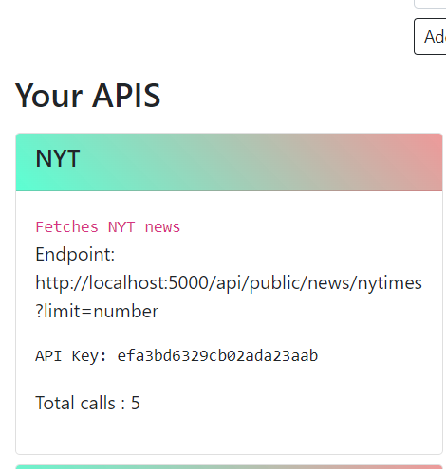

* **Password is encrypted**

Go to login page and type in the password section

